Stage 3 Modelling, Forecasting and Verification — Enhanced WP3 Progress Report
Australian Electricity Demand Forecasting Using Machine Learning and Time-Series Analytics
Project | Team | Verified run
PRT661 – Data Science Practice | Dan6 / Group 2 | Stage3 run 20260914_151706

Student | ID | Primary Stage 3 responsibility
Ashish Shrestha | S388084 | Random Forest A/B; chronological screening; four-month backtesting; regional selection
Bishal Dahal | S388095 | Feature-safety gate; Naive48/Naive336; metrics; skill vs naive; actual verification
Sudip Lamichhane | S388085 | SARIMA/SARIMAX; live weather-vintage update; AEMO secondary benchmark
Suraj Raut | S391201 | XGBoost A/B; recursive engine; lag provenance; frozen four-month forecast

Verified Stage 3 outcome All six regions reached MODEL_READY. The pipeline evaluated 108 screening runs and 144 four-month backtests (252 historical candidate runs), selected one production model per region, produced 5,856 half-hourly forecast intervals per region for September–December 2026, and verified 3,765 September intervals that were deliberately excluded from training. Pooled live verification MAE is 207.3 MW and pooled sMAPE is 7.91%.

1. Executive Summary
WP3 converts the validated Stage 2 datasets into an auditable forecasting system rather than a one-off model fit. The implemented pipeline first checks that the Stage 2 feature contract is safe, evaluates eight candidate forecasting approaches on historical four-month windows, chooses one model independently for each region, freezes a September–December 2026 forecast, then verifies that forecast against current-month actuals that were never allowed into training. A second live/weather-informed forecast vintage is kept separately so operational updates can be compared without rewriting the original prediction.
The central result is that Random Forest is the only model family selected in the final six-region run: Feature Set A (no direct future weather) is selected for NSW1, QLD1, VIC1 and TAS1, while Feature Set B is selected for SA1 and WA. The selected models improve on the best seasonal-naive benchmark by 26.5%–34.8% in mean four-month MAE. However, weather does not provide a consistent advantage across all regions, and forecast error generally grows as the recursive horizon moves farther away from observed history. Those are useful findings because they change the next project priorities: model monitoring, uncertainty, per-region tuning and richer forecast-weather vintages are more important than simply adding more features.
This report also documents how the implemented system differs from the Assessment 1 design. The original proposal called for per-region models, chronological validation, seasonal-naive and SARIMA baselines, Random Forest/Gradient Boosting, correction-aware verification and dual dashboards. Stage 3 now completes the core forecasting and verification engine for six regions, but correction-aware re-scoring, uncertainty intervals, automatic scheduling and dashboards remain next-stage work.

2. Evidence Base and Report Scope
Evidence source | What was inspected | Purpose in this report
Stage 3 validation outputs | model_selection, four_month_backtest_scores, current-month verification, A/B comparisons, leakage and integrity tests | All quantitative performance claims
Forecast outputs | frozen, current, Model A, Model B and monthly summaries | 2026 horizon, forecast vintages and monthly behaviour
Benchmark outputs | AEMO source-consistency and forecast-margin files | Secondary external comparison without mislabelling it as accuracy
Explainability outputs | selected model summary and 264 feature-importance rows | What the selected Random Forest models rely on
Metadata | run_config, model/forecast manifests, dependency record and log | Cutoff, horizon, model set, software and reproducibility
Assessment 1 design | architecture, model family, validation, risk and dashboard commitments | Plan-versus-implementation evaluation

Interpretation rule A result is described as “verified” only when the relevant output file contains later actual demand for the same target. AEMO pre-dispatch is treated as a divergence benchmark because its Scheduled Demand target is not automatically identical to the project Operational Demand target.

3. Final Architecture: Data Acquisition to Stage 3 Completion
The project is now a three-stage handoff architecture. Each stage produces a timestamped evidence package that the next stage consumes without modifying the previous stage. This separation is important for reproducibility: raw data can be traced to source, preprocessing decisions can be audited separately from model fitting, and forecast outputs remain linked to the exact feature contract and cutoff that created them.
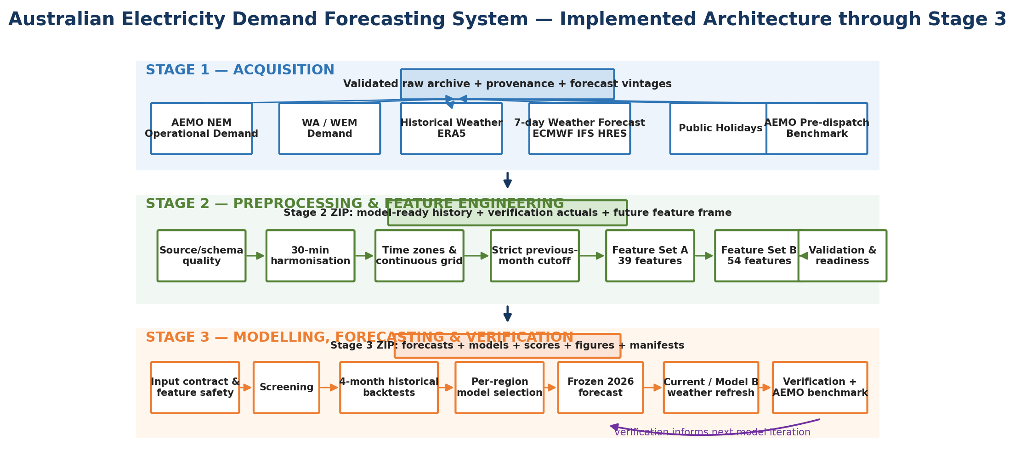
Figure 1. Implemented system architecture through Stage 3. Stage 1 preserves source provenance and weather vintages; Stage 2 harmonises and engineers forecast-safe features; Stage 3 evaluates, selects, forecasts and verifies.
Stage | Implemented responsibility | Main handoff
1 – Acquisition | NEM and WA demand; historical weather; genuine 7-day forecast weather; holidays; AEMO pre-dispatch benchmark; provenance and archive snapshots | Validated Stage 1 archive
2 – Preprocessing | Source/schema checks; mixed-frequency handling; 30-minute grid; time-zone resolution; strict previous-month cutoff; feature engineering; Model A/B contracts; readiness tests | Stage 2 ZIP with model-ready history, verification-only actuals and future feature frame
3 – Modelling | Safety gate; screening; historical four-month backtests; per-region selection; recursive forecasts; current verification; explainability; benchmark and archive verification | Stage 3 ZIP with forecasts, models, validation, figures and manifests

A non-technical way to read the architecture is: Stage 1 asks “what data did we receive?”, Stage 2 asks “can these sources be made comparable without inventing information?”, and Stage 3 asks “which forecasting method survives a fair historical test and how well does the resulting 2026 forecast perform when reality arrives?”

4. Assessment 1 Design → Current Implementation
Assessment 1 commitment | Current WP3 position | Evidence / consequence
Seven-region concept | Six regions currently reach Stage 3: NSW1, QLD1, VIC1, SA1, TAS1 and WA. NT is not in the accepted demand pipeline. | The current run_config and manifests contain six regions; scope is narrower but executable.
Per-region forecasting | Implemented: each region is evaluated and selected separately. | Different regions select A/B feature families; metrics are reported region by region.
Seasonal naive baseline | Implemented as Naive48 and Naive336. | Every accepted production model beats the best naive by 26.5%–34.8%.
SARIMA statistical tier | Implemented, plus SARIMAX. | Useful negative result: both statistical variants generally underperform the tree ensembles on the four-month horizon.
Random Forest / Gradient Boosting | Random Forest retained; XGBoost used as the boosting family. | Random Forest is selected in all six regions.
Strict chronological evaluation | Implemented with screening plus four-month analogue backtests at Sep 2023/2024/2025 origins. | No random shuffling; origin-dependent features rebuilt from pre-origin information.
Correction-aware verification | Partly implemented in source workflow but not carried into final Stage 3 re-scoring logic. | Open risk and next-stage requirement.
Dual dashboards | Not yet implemented in WP3. | Stage 3 now produces the data and figure artefacts those dashboards require.
Hierarchical reconciliation / deep learning | Still stretch items. | Not required to establish the current baseline system.

Why this matters Progress is not measured by whether the final system looks identical to the proposal. It is measured by whether changes are documented, technically justified, and supported by reproducible evidence. Stage 3 narrows some scope while materially strengthening the forecasting and verification logic.

5. Team Collaboration and the Questions the Group Had to Resolve
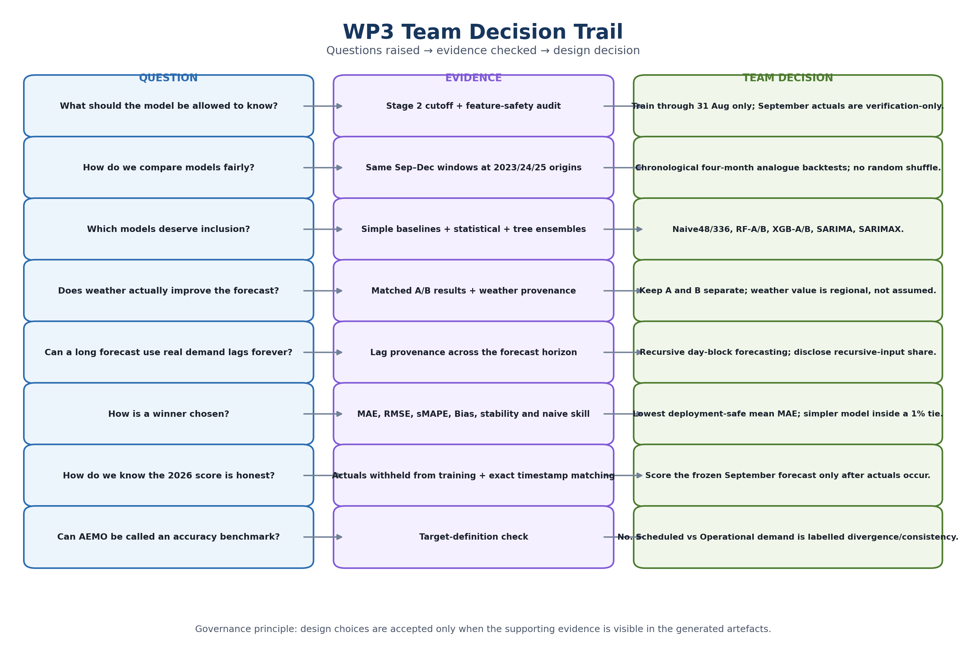
Figure 2. WP3 team decision trail. Candidate ownership is separated from scoring and verification so the final result is reviewed from multiple technical perspectives.
The integrated pipeline was not produced by simply concatenating four modules. Several decisions cut across all workstreams and therefore had to be resolved jointly. The most important design questions and the implemented answers are summarised below.

Question raised by the team | Decision implemented
What exactly are we forecasting? | Half-hourly Operational Demand in MW for six regions, not price, energy consumption or AEMO Scheduled Demand.
Where does training stop? | At 31 August 2026 23:30 for the September run. September actual demand is verification-only.
How can eight candidates be compared fairly? | All candidates face the same historical analogue windows and the same four-month deployment horizon; screening is only a preliminary failure filter.
How do we stop historical backtests from “knowing the future”? | Profiles and climatology are rebuilt separately for each origin, realised target-period weather is hidden, and lag provenance is tracked.
Why keep simple naive models? | A complex model is not useful if it cannot beat the assumption that demand repeats yesterday or last week.
Why use both Model A and Model B? | They isolate the incremental value of weather: A uses demand/calendar/history; B adds weather features and provenance.
Why was Random Forest selected? | Not because of preference: it produced the lowest deployment-safe mean four-month MAE in every region under the final selection rules.
Why not call the AEMO comparison accuracy? | The AEMO benchmark is Scheduled Demand / pre-dispatch and the project target is Operational Demand; it is a relationship/divergence check.
What makes the 2026 score genuinely out-of-sample? | Current-month actuals were separated before modelling and never entered the training features.
What should happen next? | Fix the interval-labelling warning, add correction-aware re-scoring and uncertainty, tune per region, archive more weather vintages, and build the two dashboards.

6. Stage 3 Modelling Design
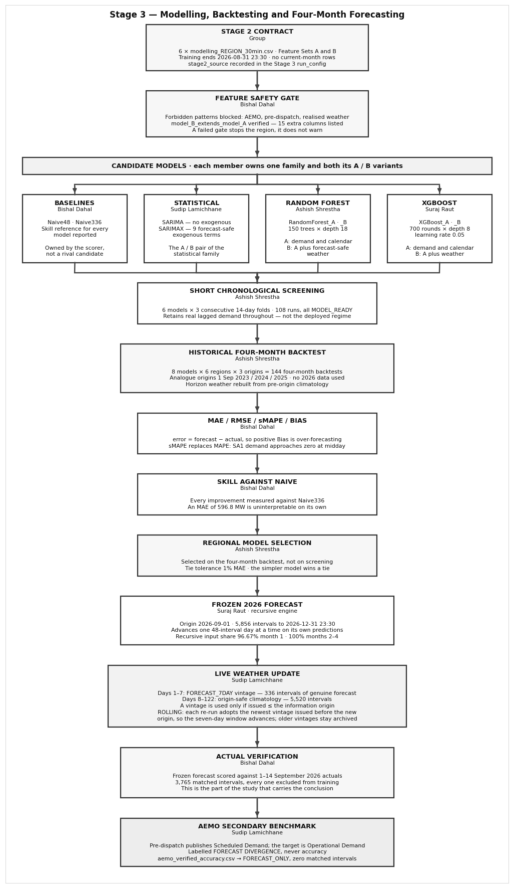
Figure 3. Final Stage 3 modelling workflow. Candidate models first pass a contract/safety gate, are screened, then face the real four-month backtest before selection. Production forecasts are stored as separate vintages and verified later.
The design deliberately separates two evaluation levels. The short chronological screening stage prevents obviously broken configurations from consuming the full runtime. It does not select the winner. The decisive test is the recursive four-month backtest, because that is the horizon the final system actually deploys. This distinction became important because short-horizon rankings and long-horizon rankings do not always agree.

7. Historical Backtesting, Recursion and Leakage Control
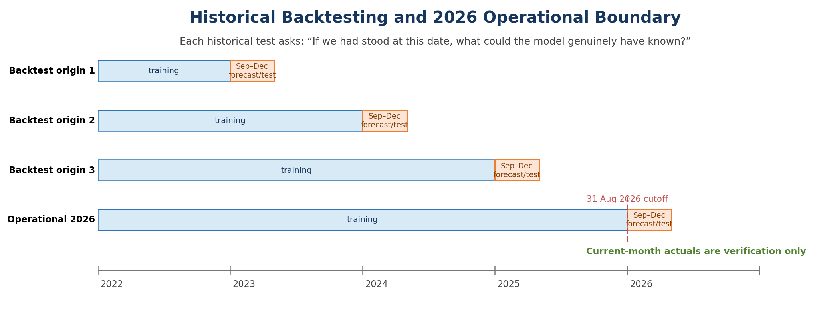
Figure 4. Historical analogue backtesting. Each September origin recreates the information boundary that would have existed at that date. The 2026 operational run uses the same logic, with a strict 31 August training cutoff.
Each backtest asks a counterfactual operational question: “If the team had stood at 1 September of this historical year, trained only on earlier data, and forecast the next four months, what error would have resulted?” For the current September run, the available analogue origins are 2023, 2024 and 2025. This is more demanding than a random split because the model must extrapolate forward through seasonality, holidays and changing demand level.
Demand lags also become recursive. During the first day, some lag references still point to actual historical demand. Later, lag_48, lag_96 and lag_336 increasingly refer to the model’s own prior forecasts. The forecast CSV therefore records whether each lag came from ACTUAL_HISTORY, RECURSIVE_FORECAST or MISSING. In the frozen September forecast, the recursive-input share is 96.67% during month one and 100% in months two to four.
Leakage / safety evidence | Result | Meaning
Leakage tests | 78/78 PASS | Training ends before each origin; current-month actuals do not enter frozen training; recursive lag provenance is consistent.
Feature safety audit | 8/8 PASS | AEMO/pre-dispatch/market requirement columns are excluded from predictors; B extends A.
Origin feature rebuild | 24 audit records | Historical profile/climatology values are rebuilt from each origin rather than copied from a later information state.
Rolling-window self-test | 5/5 PASS | September, December→March and January horizon logic works without hard-coded months.

Why the per-origin rebuild is important A historical row can be leakage-safe when created in Stage 2 but still be unsafe for an earlier backtest origin if its monthly profile was calculated using years that had not happened yet. Stage 3 therefore rebuilds those origin-dependent features again for each historical test.

8. Why These Forecasting Models Were Chosen
The candidate set is intentionally diverse rather than large. It compares simple seasonal repetition, classical statistical time-series modelling, nonlinear tree ensembles, and weather/no-weather feature families. This directly tests the modelling tiers proposed in Assessment 1 while keeping the comparison explainable to a project panel.
Candidate | Role in the experiment | Why it is useful | Main limitation on this project
Naive48 | Daily seasonal baseline | Repeats the same half-hour from the previous day; establishes a minimum standard. | Cannot adapt to trend or calendar effects.
Naive336 | Weekly seasonal baseline | Repeats the same half-hour from the previous week; strong benchmark for weekly load cycles. | Cannot adapt to changing conditions.
RandomForest_A | ML with 39 demand/calendar/history features | Nonlinear, robust, naturally handles interactions and exposes feature importance. | Recursive horizon can still accumulate error; no future weather.
RandomForest_B | ML with 54 features including weather | Tests whether weather adds measurable value on top of A. | Only seven days of genuine live forecast weather; later horizon relies on climatology.
XGBoost_A/B | Boosted-tree alternative | Tests whether sequential boosting improves on bagged trees. | More tuning-sensitive; did not beat RF in the final selection.
SARIMA | Classical statistical benchmark | Represents the time-series model explicitly proposed in Assessment 1. | Long seasonal extrapolation is computationally expensive and less stable over thousands of steps.
SARIMAX | SARIMA plus exogenous variables | Tests whether future-known exogenous structure improves the classical model. | Convergence/extrapolation warnings reduce deployment confidence.

9. Backtest Results and Final Model Selection
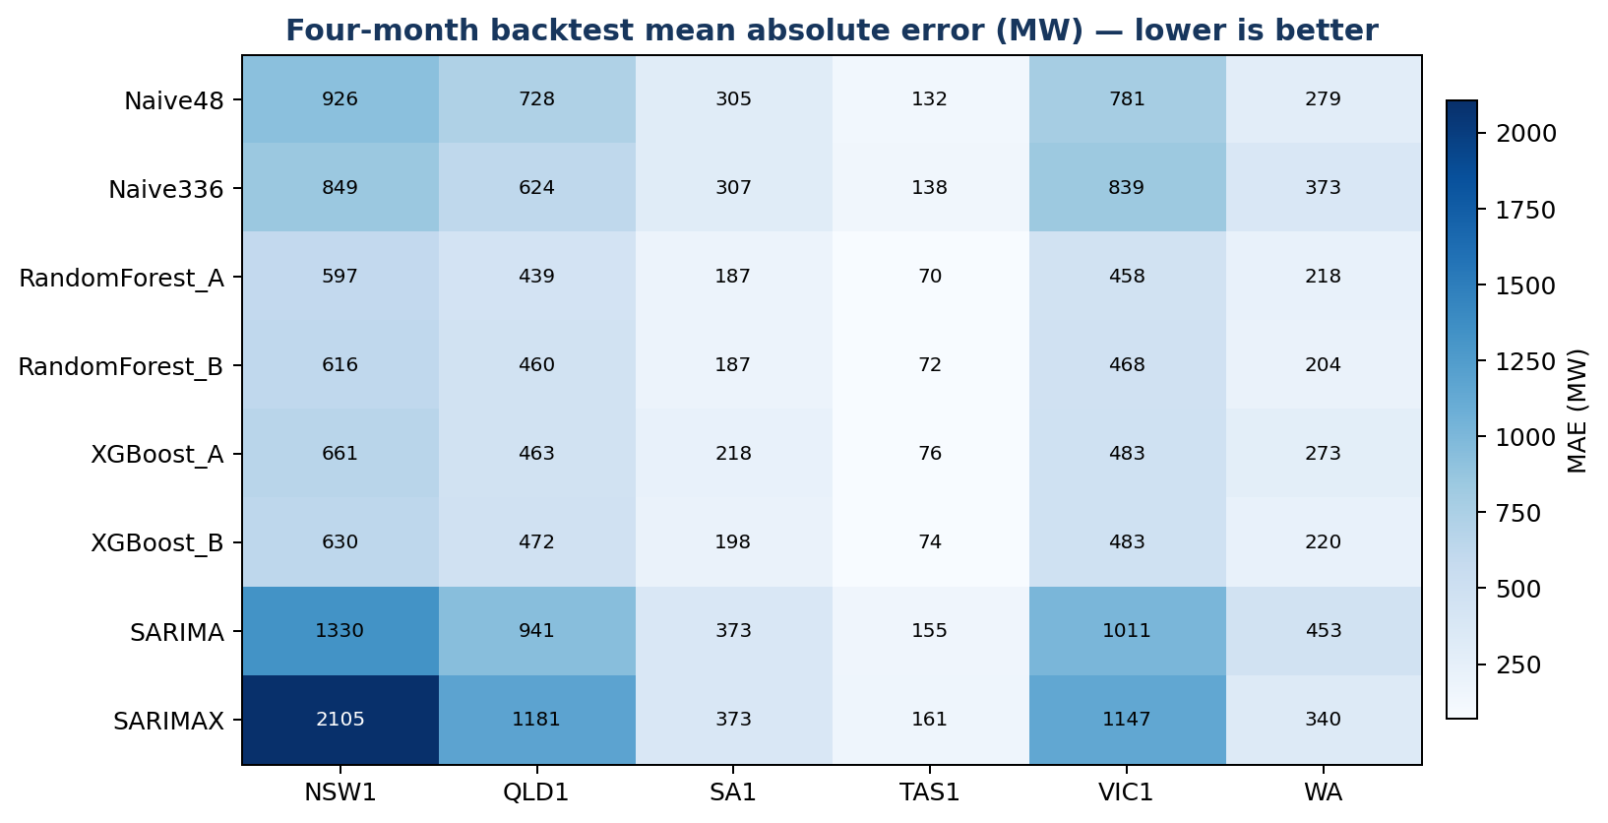
Figure 5. Mean four-month MAE for all model families and regions. Lower values indicate better forecasting performance. The tree ensembles consistently sit below the seasonal and statistical alternatives.
Region | Selected model | Set | MAE | RMSE | sMAPE | Bias | Skill vs naive
NSW1 | RandomForest_A | A | 596.8 | 886.1 | 9.04% | -46.4 | +27.9%
QLD1 | RandomForest_A | A | 439.1 | 624.6 | 7.54% | -183.5 | +28.3%
VIC1 | RandomForest_A | A | 458.2 | 641.0 | 11.39% | +48.1 | +32.2%
SA1 | RandomForest_B | B | 183.1 | 273.2 | 24.73% | +31.3 | +34.8%
TAS1 | RandomForest_A | A | 70.2 | 88.8 | 6.84% | +41.3 | +32.8%
WA | RandomForest_B | B | 206.5 | 305.9 | 11.50% | -72.1 | +26.5%

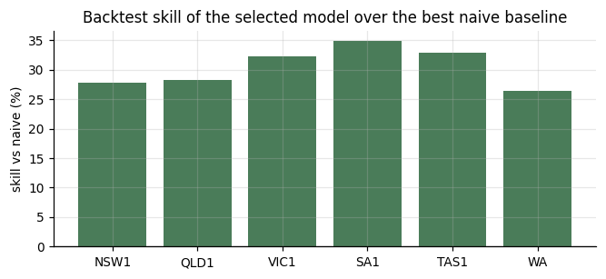
Figure 6. Skill of the selected model over the best seasonal-naive baseline. Every region exceeds the benchmark by more than 26%.
Random Forest is selected in all six regions, but that does not mean one universal model is fitted across Australia. Each region is trained and scored separately. Four regions select the 39-feature no-weather configuration, while SA1 and WA select the 54-feature weather configuration. The result supports Assessment 1’s decision to model regions independently because scale, climate and load structure differ materially.
The statistical models provide an important negative result. SARIMA and SARIMAX were not removed simply because they were slower: they were implemented and scored. Their four-month errors are generally above the seasonal-naive benchmarks and SARIMAX also produces warning/failure cases. This means the project has evidence for not selecting them, rather than an untested assumption.

10. Did Weather Help? Model A versus Model B
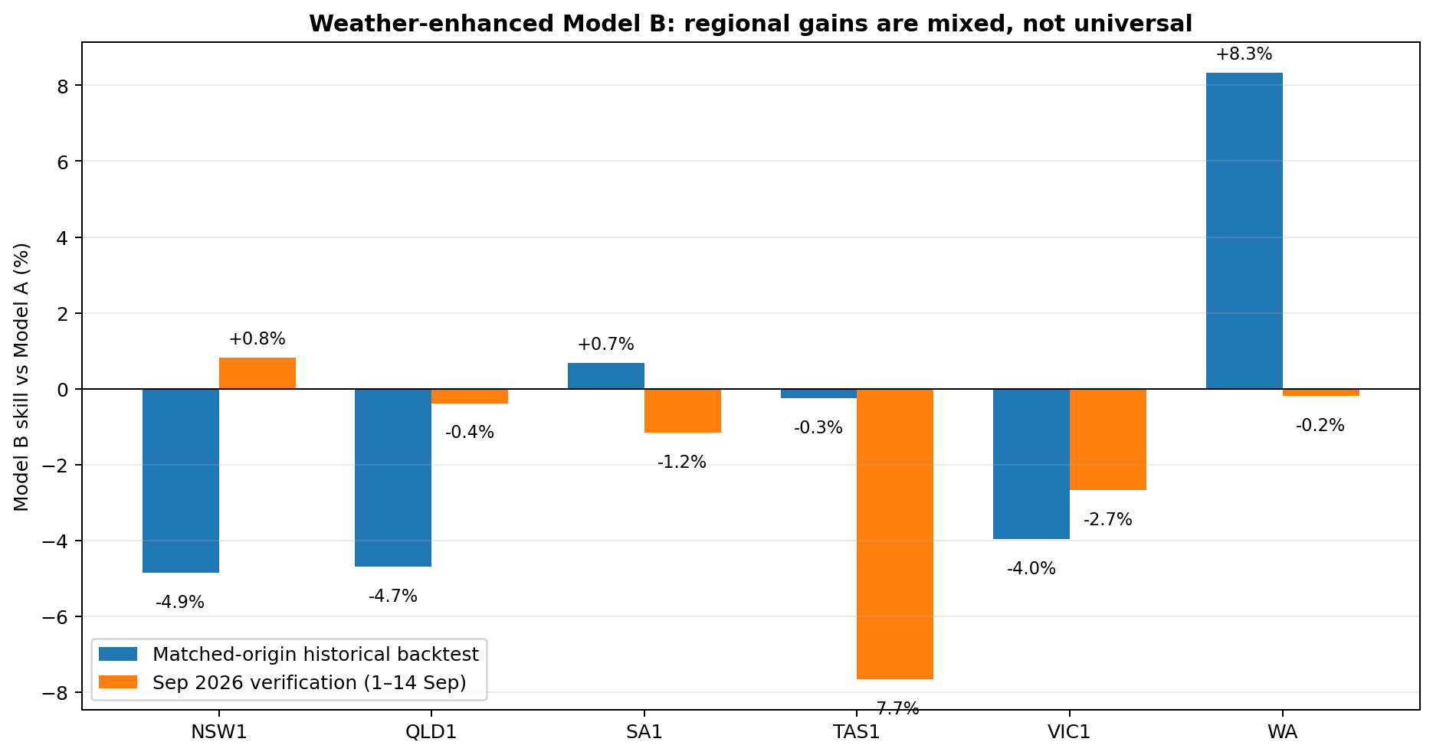
Figure 7. Incremental weather skill of Model B relative to Model A. Positive values favour B. Historical and live 2026 evidence is mixed, so weather is retained as a tested feature family rather than assumed to improve every region.
Region | A champion | B champion | A backtest MAE | B backtest MAE | Backtest weather gain | Sep verification gain
NSW1 | RandomForest_A | RandomForest_B | 596.8 | 629.0 | -5.4% | +0.8%
QLD1 | RandomForest_A | RandomForest_B | 439.1 | 490.8 | -11.8% | -0.4%
SA1 | RandomForest_A | RandomForest_B | 187.1 | 183.1 | +2.1% | -1.2%
TAS1 | RandomForest_A | XGBoost_B | 70.2 | 71.5 | -1.9% | -7.7%
VIC1 | RandomForest_A | RandomForest_B | 458.2 | 461.7 | -0.8% | -2.7%
WA | RandomForest_A | RandomForest_B | 218.4 | 206.5 | +5.4% | -0.2%

The key interpretation is not that weather “failed”. A genuine weather forecast covers only 15–21 September in the current Stage 2 package, while the operational forecast extends to 31 December. For most of the horizon, Model B therefore uses origin-safe climatology rather than knowledge of the actual future weather. Historical backtests also hide realised target-period weather to avoid leakage. Under those constraints, weather produces a meaningful four-month improvement in WA and a small improvement in SA1, while the other regions favour Model A. In current September verification, only NSW1 shows a small Model B improvement in MAE; the other gains are neutral or negative.
Decision implication Keep both A and B in the architecture. Model B is useful as a controlled experiment and as a near-term live forecast when genuine weather is available, but it should not be assumed to dominate the full four-month horizon until more archived forecast-weather vintages exist.

11. 2026 Verification: What Happened When Reality Arrived?
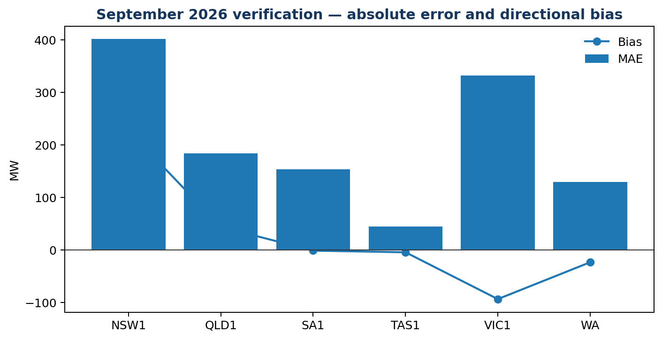
Figure 8. September 2026 verification of the frozen forecast. MAE measures absolute error; Bias shows whether the forecast systematically sits above or below actual demand.
Region | Intervals | MAE | RMSE | sMAPE | Bias | Median AE
NSW1 | 625 | 401.2 | 495.4 | 6.27% | +227.3 | 346.5
QLD1 | 625 | 184.3 | 286.7 | 3.91% | +44.1 | 95.5
SA1 | 625 | 154.0 | 234.0 | 19.31% | -1.1 | 86.5
TAS1 | 625 | 44.6 | 56.8 | 4.40% | -4.1 | 36.6
VIC1 | 625 | 332.2 | 416.7 | 6.84% | -93.2 | 298.2
WA | 640 | 129.5 | 177.4 | 6.78% | -23.1 | 94.4

Across all 3,765 verified half-hours, pooled MAE is 207.3 MW, RMSE is 313.3 MW and pooled sMAPE is 7.91%. This score is especially valuable because these September actuals were kept out of training at both Stage 2 and Stage 3.
Bias reveals information that MAE cannot. NSW1 is over-forecast on average (+227.3 MW), while VIC1 and WA under-forecast on average (−93.2 MW and −23.1 MW). At the highest-demand decile, all six regions show negative mean bias. That means peak conditions are still systematically harder than average conditions even when overall MAE is acceptable. The system should therefore monitor peak-period bias separately rather than relying on a single aggregate error number.
Region | Top-decile intervals | Demand threshold MW | Peak bias MW | Peak MAE MW
NSW1 | 63 | 8438.3 | -40.0 | 332.5
QLD1 | 63 | 6946.0 | -23.5 | 73.7
VIC1 | 63 | 6508.8 | -413.0 | 435.6
SA1 | 63 | 1658.7 | -83.1 | 114.5
TAS1 | 63 | 1183.8 | -59.0 | 59.6
WA | 64 | 2491.2 | -66.4 | 116.5

Why SA1 has a high sMAPE SA1’s September MAE is 154.0 MW, but sMAPE is 19.31%. SA1 operates on a much smaller and sometimes near-zero demand scale than NSW/VIC, so percentage error expands even when absolute MW error is not the largest. This is why the report always presents MW metrics and percentage metrics together.

12. Long-Horizon Behaviour: Error Growth under Recursion
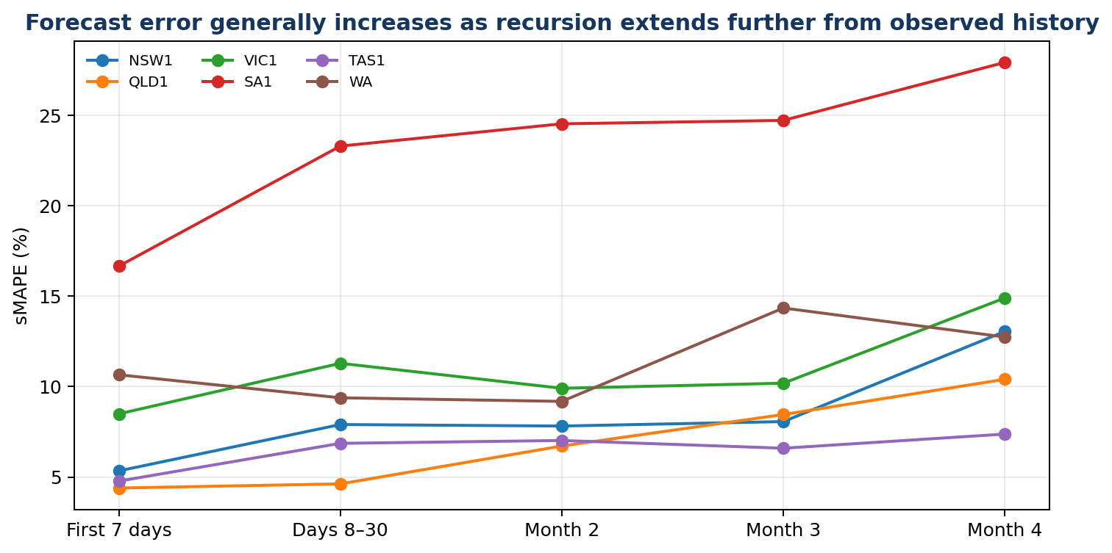
Figure 9. Selected-model sMAPE by forecast segment. Error generally rises as the horizon moves away from observed history and recursive lags depend increasingly on earlier model predictions.
Region | First 7d | Days 8–30 | Month 2 | Month 3 | Month 4 | Stable origins
NSW1 | 5.34% | 7.91% | 7.82% | 8.07% | 13.05% | 3
QLD1 | 4.39% | 4.62% | 6.72% | 8.46% | 10.41% | 3
VIC1 | 8.50% | 11.29% | 9.91% | 10.19% | 14.90% | 3
SA1 | 16.66% | 23.30% | 24.53% | 24.72% | 27.93% | 2
TAS1 | 4.78% | 6.86% | 7.02% | 6.59% | 7.38% | 3
WA | 10.66% | 9.38% | 9.18% | 14.35% | 12.74% | 2

The project should therefore treat a four-month point forecast differently from a day-ahead forecast. The first week is still anchored strongly by recent actual demand. By months two to four, all lag inputs are recursive, so the model is effectively using its own earlier estimates plus deterministic calendar/history profiles. The rising error curve is not a software failure; it is a structural property of long recursive forecasting and should be communicated as uncertainty in the final dashboard.

13. Forecast Products Produced by Stage 3
Stage 3 produces multiple forecast products because “the forecast” is not one file. The frozen vintage answers the audit question “what did we predict at the formal month boundary?”, while the live/Model B vintage answers “what would we issue now with the newest forecast-safe information?”. Keeping them separate prevents hindsight from rewriting history.
Product | Purpose | Current 2026 behaviour
Frozen forecast | Immutable reference used for later accuracy verification | 1 Sep–31 Dec 2026, 5,856 half-hours per region, trained only through 31 Aug
Current/live forecast | Operational re-issue with current forecast-safe information | Same four-month window; Model B can use the current 7-day weather vintage
Model A four-month | Weather-independent structural forecast | Available for all six regions across the full horizon
Model B rolling/live | Weather-informed alternative | Genuine 7-day forecast weather, then climatology fallback
Monthly summary | Decision-support aggregation | Mean, median, min, max, peak timestamp, energy-equivalent summary and recursive share

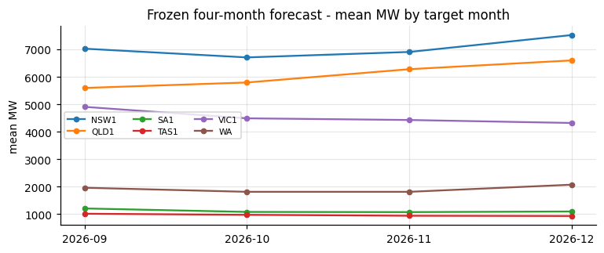
Figure 10. Frozen forecast monthly means by region. The figure translates 5,856 half-hourly predictions into a higher-level seasonal outlook for September–December 2026.
Region | Dec mean MW | Dec peak MW | Predicted peak timestamp
NSW1 | 7521 | 10748 | 2026-12-17 17:00:00
QLD1 | 6598 | 9100 | 2026-12-21 19:00:00
VIC1 | 4321 | 6095 | 2026-12-28 18:30:00
SA1 | 1099 | 1752 | 2026-12-18 19:30:00
TAS1 | 935 | 1080 | 2026-12-07 20:30:00
WA | 2075 | 3403 | 2026-12-24 18:00:00

These monthly values are forecasts, not realised demand. Their purpose at WP3 is to demonstrate that the selected models can produce a complete, internally consistent long-range trajectory. Accuracy for October–December cannot be claimed until those actuals exist.

14. Explainability: What the Selected Random Forests Use
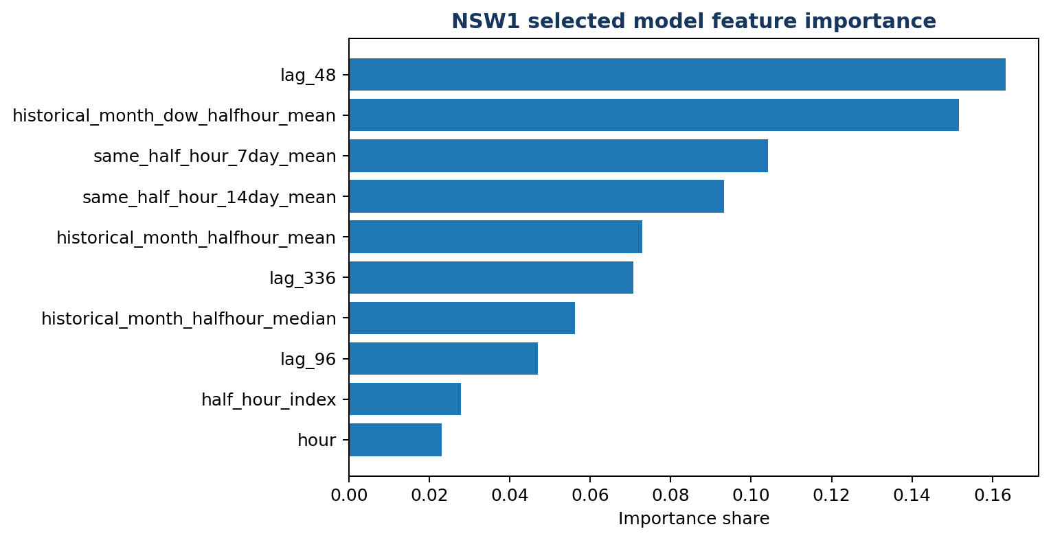
Figure 11. NSW1 feature importance. Recent daily/weekly demand and historical half-hour profiles dominate the selected Model A.
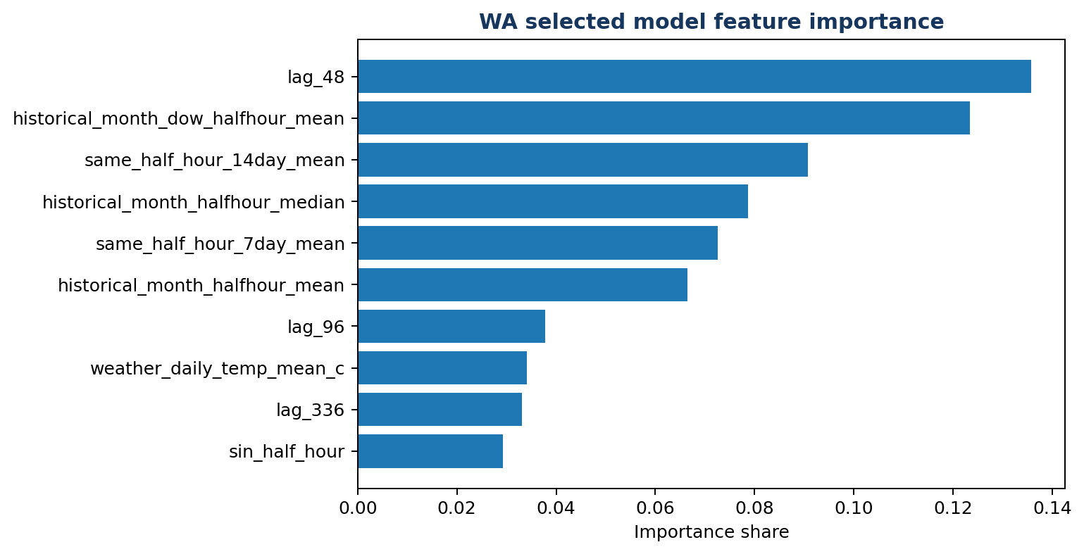
Figure 12. WA feature importance. The selected Model B still relies primarily on demand history and seasonal profiles; weather contributes additional but smaller importance.
Region | Selected model | Three highest-importance features
NSW1 | RandomForest_A | lag_48 (0.163); historical_month_dow_halfhour_mean (0.152); same_half_hour_7day_mean (0.104)
QLD1 | RandomForest_A | lag_48 (0.164); historical_month_dow_halfhour_mean (0.144); same_half_hour_7day_mean (0.122)
SA1 | RandomForest_B | historical_month_dow_halfhour_mean (0.146); historical_month_halfhour_mean (0.109); historical_month_halfhour_median (0.095)
TAS1 | RandomForest_A | same_half_hour_7day_mean (0.154); same_half_hour_14day_mean (0.140); lag_48 (0.129)
VIC1 | RandomForest_A | historical_month_dow_halfhour_mean (0.165); same_half_hour_7day_mean (0.113); lag_48 (0.103)
WA | RandomForest_B | lag_48 (0.136); historical_month_dow_halfhour_mean (0.123); same_half_hour_14day_mean (0.091)

Across regions, the leading predictors are variations of lag_48, same-half-hour rolling summaries and historical month/day-of-week/half-hour profiles. This is consistent with electricity demand having strong daily and weekly repetition. Feature importance describes how often/strongly the fitted trees used a variable for prediction; it does not establish that the variable causes demand.

15. AEMO Benchmark: Useful Context, Not a Competition Score
AEMO pre-dispatch is deliberately excluded from all model features. It is used only after forecasting as a secondary external reference. The reason is target semantics: the project forecasts Operational Demand, while the dashboard/pre-dispatch field is Scheduled Demand / TOTALDEMAND. High correlation therefore demonstrates relationship, not identity.
Region | Overlap | Mean absolute source difference MW | Correlation | Status
NSW1 | 19 | 136.6 | 0.987 | TARGET_MISMATCH_SECONDARY_BENCHMARK
QLD1 | 19 | 89.7 | 0.995 | TARGET_MISMATCH_SECONDARY_BENCHMARK
SA1 | 19 | 71.8 | 0.966 | TARGET_MISMATCH_SECONDARY_BENCHMARK
TAS1 | 19 | 0.0 | 1.000 | TARGET_MISMATCH_SECONDARY_BENCHMARK
VIC1 | 19 | 165.0 | 0.961 | TARGET_MISMATCH_SECONDARY_BENCHMARK

Region | Available horizon | Matched intervals | Mean margin MW | Mean |margin| MW
NSW1 | 37.5 h | 75 | -5.0 | 259.4
QLD1 | 37.5 h | 75 | -85.2 | 121.3
SA1 | 37.5 h | 75 | -156.6 | 156.6
TAS1 | 37.5 h | 75 | +70.2 | 80.4
VIC1 | 37.5 h | 75 | -217.9 | 296.2

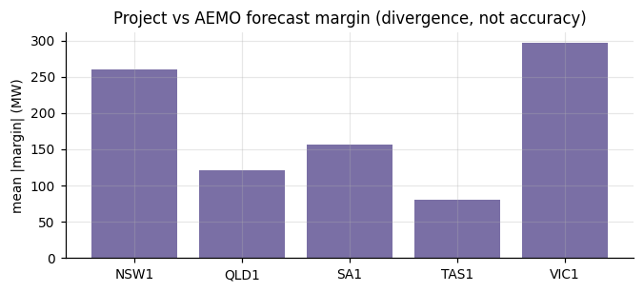
Figure 13. Project versus AEMO forecast margin over the actual 37.5-hour pre-dispatch horizon. The chart measures divergence only; neither source is scored as the “winner”.
WA is correctly absent from the AEMO NEM benchmark. The five NEM regions have 75 matched forecast intervals over 37.5 hours. The separate verified-accuracy file remains FORECAST_ONLY because the later actual period for those AEMO forecast timestamps had not yet arrived in the Stage 2 actuals when this run was produced.

16. Quality Assurance and Reproducibility
Control | Result | Interpretation
Region modelling status | 6 MODEL_READY; 0 warning; 0 failed | Every target region produced an accepted forecast.
Leakage tests | 78/78 PASS | No detected future target leakage in the tested contracts.
Feature safety | 8/8 PASS | Forbidden benchmark/context columns do not enter predictors.
Forecast integrity | 110/120 PASS; 10 warnings | Warnings are visible rather than suppressed.
December/January reusability | 5/5 PASS | Month/year crossover logic is reusable.
Stage 3 archive verification | 41/41 PASS | Required artefacts remain present after ZIP creation.
Dependencies | No required package missing | Run records Python and library versions.

Known integrity warning All 10 warnings come from the same interval-label convention issue: NEM demand uses interval-ending labels, while the Stage 2 future frame is labelled 00:00–23:30 as interval starts. Forecast-vs-actual scoring uses exact timestamps, so the reported scores are still matched correctly, but the boundary labels should be corrected before the final operational release.

17. Risks, Limitations and Assessment 1 Commitments
Risk / limitation | Status after WP3 | Evidence | Next control
Large multi-region volume | Controlled | Full six-region Stage 3 run completed; all regions MODEL_READY | Keep staged ZIP handoffs and quick-mode testing.
AEMO corrections missed or mishandled | OPEN / partially addressed | Correction-aware re-scoring is not in the integrated Stage 3 pipeline | Add correction listener after scheduled runner; re-score immutable forecast vintages.
Per-region accuracy diverges | Controlled but ongoing | MAE/sMAPE differ materially by region; per-region models and reports already used | Tune and monitor by region, not national average only.
Recursive long-horizon error | OPEN structural risk | sMAPE generally increases by month four; recursive share reaches 100% | Add uncertainty bands; evaluate direct/multi-output alternatives if needed.
Weather forecast horizon too short | OPEN | 7 days genuine weather versus roughly 4-month demand horizon | Archive more weather vintages; consider appropriate longer-range outlook variables.
Interval-label boundary mismatch | OPEN technical defect | 10/120 integrity checks are warnings on NEM labels | Align future-frame labels to market interval convention.
Model B historical evidence thinner | OPEN | B selections rely on two stable origins in the family summary | Increase archived forecast-weather history and repeat backtests.
Uncertainty not communicated | OPEN | Current outputs are point forecasts only | Add prediction intervals / quantile forecasts before dashboard release.
Shared hyperparameters across regions | OPEN enhancement | One RF/XGB configuration is used for all regions | Perform nested, time-budgeted per-region tuning using only pre-origin data.
Rooftop solar / spatial weather not directly observed | Data limitation | Not present in current source/feature contracts | Document limitation; evaluate additional authoritative covariates only if reproducible.
Short live verification window | OPEN by time | Only September 1–14 is currently verifiable | Re-run verification as Oct–Dec actuals arrive.

The Assessment 1 risk register specifically identified scale, correction handling and regional accuracy divergence. WP3 materially reduces the scale risk and implements per-region accuracy reporting, but correction-aware re-scoring remains the clearest inherited gap. The new risks above are not scope creep; they are risks discovered only after the real recursive system existed and could be tested.

18. Next Direction of the Project
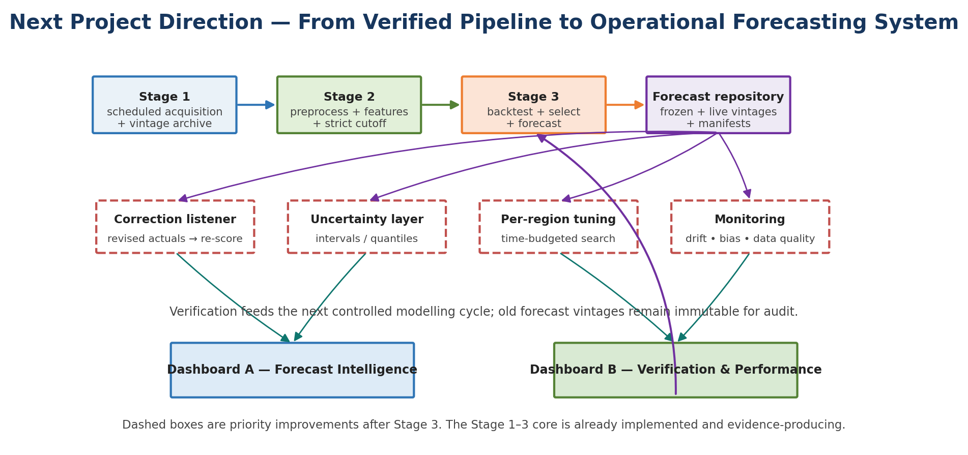
Figure 14. Proposed next architecture. Dashed components are the priority additions after Stage 3; the implemented Stage 1–3 core remains unchanged and auditable.
- Correct the NEM interval-label convention in the Stage 2 future frame, then rerun the integrity suite.
- Introduce a scheduled pipeline runner that archives every acquisition, weather forecast and demand forecast vintage.
- Restore correction-aware verification so revised AEMO actuals trigger re-scoring of the original immutable forecast rather than a rewritten forecast.
- Add uncertainty intervals or quantile forecasts; the current long-horizon point forecast should not be shown in a dashboard without uncertainty.
- Run per-region hyperparameter tuning inside chronological folds only, preserving the previous-month cutoff and never tuning on current verification actuals.
- Accumulate genuine forecast-weather vintages so Model B can be evaluated on what weather was actually known at historical origins rather than climatology alone.
- Build Dashboard A (forecast intelligence) and Dashboard B (verification/performance) from the existing Stage 3 outputs, with model/vintage identifiers visible to users.
- Continue monthly verification through October–December 2026 and establish drift/bias monitoring, especially at high-demand intervals.

19. WP3 Contribution and Integration Summary
Member | Primary contribution in Stage 3 | Evidence of integration
Ashish Shrestha | Random Forest A/B; short chronological screening; historical four-month backtesting; regional model selection. | The integrated run contains 108 screening runs, 144 four-month backtests and one auditable selection reason per region.
Bishal Dahal | Feature-safety gate; Naive48/Naive336 baselines; MAE/RMSE/sMAPE/Bias; skill-vs-naive analysis; current actual verification. | 8/8 feature-safety checks PASS, seasonal baselines are present in every comparison, and 3,765 unseen intervals are scored independently.
Sudip Lamichhane | SARIMA/SARIMAX statistical family; live 7-day weather-vintage update; AEMO secondary benchmark/source semantics. | Statistical candidates remain in the full comparison, weather vintages are separated from climatology fallback, and AEMO is labelled as a target-mismatched secondary benchmark.
Suraj Raut | XGBoost A/B; recursive time-series engine; lag provenance; frozen month-start four-month 2026 forecast. | The same recursive engine produces 5,856 half-hour intervals per region and records when lag inputs switch from actual history to recursive forecasts.
All four | Stage 2 contract, previous-month cutoff, four-month horizon, A/B interpretation, final merge and review. | Shared rules are recorded in run_config, model/forecast manifests, validation summaries and the final integrated script.

The strongest evidence of collaboration is not that each person touched every line. It is that the final system contains independent checks between workstreams: input rules constrain the models, chronological logic constrains what features can know, verification scores outputs it did not generate, and source classification constrains how external comparisons are described.

20. Conclusion
WP3 completes the first full forecasting-and-verification loop of the project. The system can now move from source data to harmonised features, evaluate eight model candidates on historical deployment-like horizons, select one model per region, issue a September–December 2026 half-hourly forecast, and score that forecast against actual demand that the models never saw during training. This is a substantial progression from Assessment 1’s design proposal.
The most important outcome is not that Random Forest “won”. It is that the project now has a defensible method for deciding what wins, for explaining when the evidence is weak, and for preserving forecast vintages so future actuals can verify the claim. The next project phase should therefore focus on operational maturity—correction handling, uncertainty, tuning, forecast-vintage accumulation, dashboards and ongoing verification—rather than redesigning the core pipeline again.
Evidence basis: all quantitative results in this document were calculated from the supplied Stage 3 validation, forecast, benchmark, explainability and metadata outputs. Assessment 1 comparisons are drawn from the original proposal/design plan; unsupported commit IDs or project-management artefacts are not invented.

